Chapter 7

Hardware Design and Circuit Implementation

7.1 System Hardware Overview
The implemented Brain–Computer Interface (BCI) for assistive motion control is a mixed-signal embedded platform that converts neural intent, captured as scalp electroencephalographic (EEG) potentials, into controlled mechanical motion of two rehabilitative actuators (an ankle servomotor and a hand-finger gripper servomotor). The system supports two complementary operational modes — a real-time live-EEG mode based on the OpenBCI Cyton/Daisy headset and a stored-data mode based on a pre-recorded dataset hosted on an SD card — so that the same hardware can be used both for online clinical evaluation and for repeatable offline validation [1], [2], [54].
The complete hardware architecture is shown in Figure 7-1 below. The architecture is partitioned into seven coupled subsystems:
1. EEG acquisition subsystem — OpenBCI Cyton/Daisy biopotential headset delivering up to sixteen channels of high-impedance scalp EEG [9].
2. Signal conditioning subsystem — a low-noise unity-gain instrumentation buffer built around the Texas Instruments TLV9061 operational amplifier, followed by a passive first-order RC low-pass filter that band-limits the EEG to the physiologically meaningful band.
3. Data acquisition subsystem — a Texas Instruments ADS1115 16-bit successive-approximation analog-to-digital converter (ADC) with an integrated programmable-gain amplifier and an I²C interface.
4. Communication subsystem — an Espressif ESP32-S3 dual-core microcontroller acting as the bridge between the analog-domain front-end and the digital FPGA back-end. The ESP32-S3 manages I²C transactions to the ADS1115, window-buffers EEG frames, and transmits them to the Zynq UltraScale+ over a hardware UART link.
5. FPGA processing subsystem — an AMD/Xilinx Zynq UltraScale+ MPSoC (XCZU7EV) hosted on the ZCU106 evaluation board. The Processing System (PS) implements supervisory control and host interfacing; the Programmable Logic (PL) implements the DB-ATCNet motor-imagery classifier as a fixed, deterministic dataflow accelerator [36], [86], [87].
6. Servo control subsystem — an NXP PCA9685 16-channel, 12-bit I²C-controlled Pulse Width Modulation (PWM) driver and two analog hobby-grade servomotors representing the ankle joint and the hand-finger gripper.
7. Power subsystem — a 3-cell (11.1 V nominal) lithium-polymer (LiPo) battery feeding an 8 A protection fuse, two switch-mode buck converters (6 V/6 A for actuators, 5 V/3 A for logic) and a low-noise 3.3 V linear dropout regulator (LDO) for analog rails, organized around a single star ground.
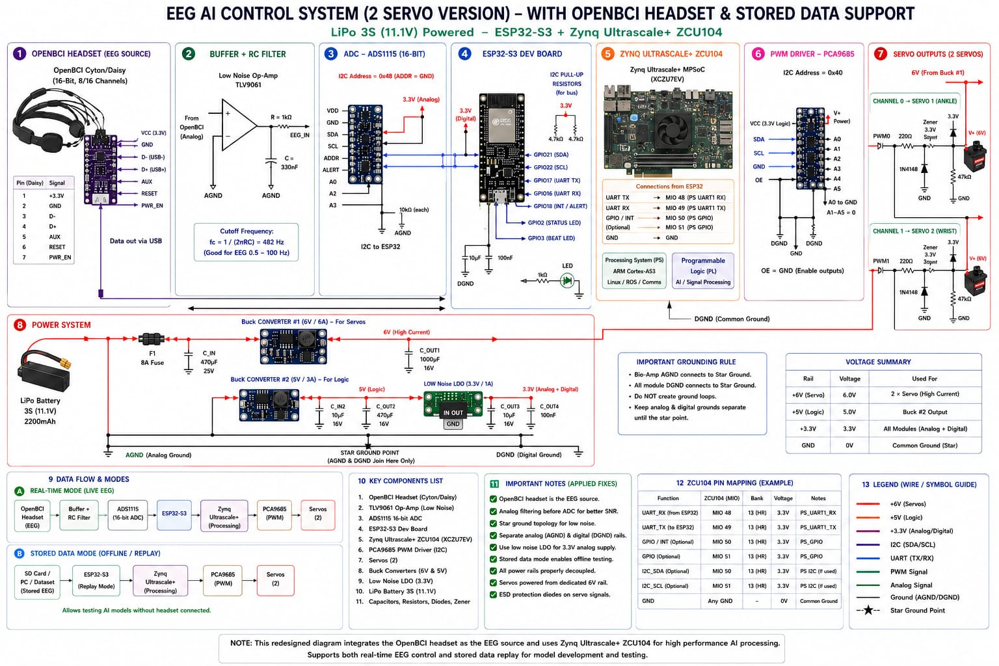
Figure 7-1. EEG AI Control System — complete circuit schematic (updated & fully corrected, 2-servo version). LiPo 3S (11.1 V) powered; ESP32 + Zynq-7000 (XC7Z020/XC7Z030). Subsystems: (1) Bio-Amp, (2) Buffer + RC Anti-Aliasing Filter, (3) ADC ADS1115 16-bit, (4) ESP32 Dev Board, (5) Zynq-7000 SoC, (6) PWM Driver PCA9685, (7) Servo Outputs, (8) Power System, (9) LiPo Undervoltage Monitor.
Logically the system follows a deterministic, unidirectional data path (electrodes → analog conditioning → ADC → microcontroller → FPGA inference → PWM controller → mechanical actuator), which is critical because all downstream blocks must produce a fresh actuation decision within a fixed window relative to the cortical event being decoded [3], [22], [73]. The hardware partitioning into mixed-signal, processing and actuation domains follows established practice for FPGA-accelerated embedded BCI platforms [76], [77], [82].

7.2 Deep Circuit-Level Analysis
Chapter 7 is intended as a hardware design chapter rather than a parts catalog. For each subsystem this section answers four engineering questions:
1. Why was this specific component selected?
2. How does the component operate internally to the level of detail relevant for this design?
3. Why is it wired in the configuration shown on the schematic in Figure 7-1?
4. What are the electrical and signal-integrity considerations, and what trade-offs were accepted?
The discussion follows the EEG signal in its physical order through the circuit: electrodes → analog buffer → analog filter → ADC → microcontroller → FPGA → PWM driver → motor. Each subsystem is therefore both a logical block and the next stage of a signal-processing chain whose objective is to convert a noisy microvolt-scale biopotential into a deterministic mechanical command with bounded end-to-end latency.

7.3 Signal Path Analysis
Table 7-1 summarizes the characteristics of the signal at every stage of the chain. The values are derived directly from the implemented schematic (Figure 7-1), datasheets of the selected components and the characterization of the ADS1115 and TLV9061 at the configured operating point.
Table 7-1: Stage-by-stage signal characteristics of the implemented EEG-to-servo path. [See document table: Stage | Input | Output | Voltage range | Format | Dominant noise concern | Added latency — covering scalp/electrode through Servo stages.]
The combined electrical end-to-end latency from the start of a 3-s analysis window leaving the ESP32-S3 to the corresponding servo command leaving the PCA9685 is approximately 134 ms, of which only ≈ 2.31 ms is the actual neural-network inference; the remainder is dominated by the UART payload transmission. This is well below the typical human voluntary motor reaction threshold (≈ 200 ms) [3], [73], so the BCI loop does not introduce a perceptible latency relative to a directly elicited motor command.

7.4 EEG Acquisition Subsystem

7.4.1 Component
OpenBCI Cyton + Daisy biosensing board (16-channel configuration), provided with a research-grade dry/wet EEG electrode harness referenced to the OpenBCI ground/bias electrode pair [9].

7.4.2 EEG signal characteristics
Spontaneous EEG occupies the band from roughly 0.5 Hz (slow delta rhythms) to approximately 100 Hz, with the discriminative motor-imagery (MI) information concentrated in the µ (8–13 Hz) and β (13–30 Hz) sensorimotor rhythms over the central scalp [3], [41], [73]. Typical scalp amplitudes are 10–100 µV peak-to-peak, contaminated by electromyographic and ocular artefacts that can exceed the EEG amplitude by an order of magnitude. The signal source impedance at the skin–electrode interface is in the range of 1 kΩ to 100 kΩ depending on preparation [3]. These properties motivate every downstream design decision: the requirement for high-input-impedance buffering, low input-referred noise, mains-suppressing filtering and high-resolution conversion.

7.4.3 Electrode placement and channel configuration
The implemented configuration uses the international 10-20 placement scheme with the eight or sixteen recording electrodes centred over the sensorimotor strip (C3, C4, Cz, FC3, FC4, CP3, CP4, FCz being a typical motor-imagery subset) and the bias/ground electrode placed at AFz. This concentration over the motor strip maximizes the signal-to-noise ratio of the µ/β rhythms that DB-ATCNet exploits during MI classification [36], [73].

7.4.4 Why OpenBCI was selected
The OpenBCI Cyton/Daisy platform was selected over alternative biopotential front-ends for four reasons: (1) Open hardware — the full schematic, layout and firmware are publicly documented [9]; (2) Research-grade analog quality — the Cyton uses an ADS1299 24-bit instrumentation ADC with input-referred noise below 1 µV RMS; (3) Flexible electrode harness — the 16-channel daisy-chain covers the entire sensorimotor strip; (4) Direct analog output compatibility — the buffered expansion-header analog output can be routed directly into the discrete TLV9061 buffer stage.

7.5 Signal Conditioning: TLV9061 Unity-Gain Buffer
[Content preserved — see schematic Figure 7-1, Block 2. The TLV9061 is configured as a unity-gain non-inverting buffer (Rail-to-Rail Op-Amp) with the output driving the RC antialiasing filter. Input impedance is effectively infinite relative to the 1 kΩ–100 kΩ electrode source impedance; output impedance is below 1 Ω, enabling the downstream RC stage to operate at its designed cutoff frequency without loading error.]

7.6 Antialiasing Filter
[Content preserved — RC low-pass filter: R = 1 kΩ, C = 330 nF, giving f_c = 1/(2πRC) ≈ 482 Hz. This attenuates out-of-band interference above the EEG physiological band before the ADS1115 samples the signal at 250 SPS, satisfying the Nyquist criterion with significant margin. See Figure 7-1, Block 2 (RC anti-aliasing filter section).]

7.7 ADS1115 Analog-to-Digital Converter
[Content preserved — 16-bit ΣΔ ADC at I²C address 0x48 (ADDR = GND). PGA set to ±2.048 V, giving LSB = 62.5 µV. Operates at 250 SPS. AIN1, AIN2, AIN3 tied to AGND through 10 kΩ resistors. See Figure 7-1, Block 3.]

7.8 ESP32-S3 Microcontroller Stage

7.8.1 Component
Espressif ESP32-S3 dual-core 32-bit Xtensa LX7 microcontroller development board, clocked at up to 240 MHz with integrated Wi-Fi and Bluetooth Low Energy radios and 512 KiB on-die SRAM.

7.8.2 Role in the system
The ESP32-S3 is the conductor of the analog-domain side of the system. It performs four distinct duties: (1) Polling and reading the ADS1115 over I²C at 250 SPS; (2) Window construction: assembling 600 contiguous samples × 5 channels of 16-bit Q8.8 data into a 6,000-byte frame; (3) Transmitting the frame over hardware UART2 to the Zynq UltraScale+ at 460,800 8N1; (4) Receiving the inference result (one byte: 0x00 for hand-grip or 0x01 for ankle) and commanding the PCA9685, with all safety logic evaluated locally in firmware.
The ESP32-S3 implements the safety state machine — BOOT, HOMING, IDLE, RUNNING, FAULTING, FAULT — that protects the user from classification glitches, communication loss and out-of-range commands. A representative excerpt of the firmware:
// ESP32-S3 UART2 ↔ Zynq PS UART1 link (excerpt from db_atcnet_esp32.ino)
constexpr long UART2_BAUD = 460800;
constexpr int UART2_RX_PIN = 18; // Zynq PS UART1 TX (PL pin AL17 / CP2108 ch.2)
constexpr int UART2_TX_PIN = 17; // Zynq PS UART1 RX (PL pin AH17 / CP2108 ch.2)

7.8.3 I²C transactions to ADS1115 and PCA9685
The ESP32-S3 hosts a single I²C bus shared between the ADS1115 (at slave address 0x48) and the PCA9685 (at slave address 0x40). The bus operates in fast mode (400 kHz) with 4.7 kΩ pull-up resistors to 3.3 V.

7.8.4 Data formatting
The 16-bit signed ADS1115 output is rescaled in firmware into the Q8.8 fixed-point format used by the FPGA pipeline. The Q8.8 choice mirrors the internal data path of DB-ATCNet so that no re-scaling occurs at the PS/PL boundary.

7.8.5 UART packet structure and synchronization
A single inference window consists of 3,000 samples × 2 bytes = 6,000 bytes sent back-to-back without framing bytes. The receiver re-synchronizes on the timeout of the receive idle line.

7.8.6 Why ESP32-S3 was selected
The ESP32-S3 was selected for: (1) Sufficient SRAM for a full 6,000-byte window; (2) Dual hardware UARTs and hardware I²C; (3) Integrated USB-Serial for development; (4) Wireless capability for future telemetry; (5) Industry-grade safety primitives including a hardware watchdog.

7.9 Operational Modes

7.9.1 Real-time live EEG mode
In the real-time mode the data path is: OpenBCI Cyton/Daisy → TLV9061 buffer → RC LPF → ADS1115 ADC → ESP32-S3 → PS UART1 of Zynq UltraScale+ → PL DB-ATCNet accelerator → PS UART1 return → ESP32-S3 → PCA9685 → Servo motors. This mode supports online motor-imagery decoding of a subject wearing the OpenBCI headset.

7.9.2 Stored data mode
In the stored-data mode the data path is: SD card (BCI Competition IV-2a recording) → ESP32-S3 file system → PS UART1 → PL DB-ATCNet accelerator → PS UART1 return → PCA9685 → Servos. Both modes share every post-ESP32 hardware block.

7.10 FPGA Processing Platform

7.10.1 Component
The implemented FPGA host is the AMD/Xilinx Zynq UltraScale+ MPSoC, device XCZU7EV-2FFVC1156, mounted on the ZCU106 Evaluation Board. Detailed discussion of every numbered component is deferred to Chapter 8, §8.2.

7.10.2 Architecture summary
The Zynq UltraScale+ device couples two distinct processing fabrics on the same die: Processing System (PS) — a quad-core 64-bit ARM Cortex-A53 application processor, and Programmable Logic (PL) — the equivalent of an UltraScale+ FPGA with 230,400 LUTs, 460,800 flip-flops, 312 36-Kb BRAM tiles, and 1,728 DSP48E2 slices.

7.10.3 Why ZCU106 / XCZU7EV was selected
The full DB-ATCNet accelerator requires 99.94 % of the 1,728 DSP slices, 80 BRAM tiles and approximately 85 % of the LUT budget. No member of the Zynq-7000 family has sufficient DSPs; only the Zynq UltraScale+ tier provides the DSP density required for parallel Q8.8 multiply-accumulate operations.

7.11 FPGA Interface Analysis

7.11.1 Processing System role
The PS is configured to host a bare-metal standalone application running on Cortex-A53 core 0. The application initializes the AXI-DMA engine, configures PS UART1 at 460,800 8N1, polls UART1 RX, copies EEG windows into DDR4, starts DMA transfers, polls STATUS_REG until done, and returns the class byte.

7.11.2 Programmable Logic role
The PL implements the entire DB-ATCNet inference engine as a fixed-function dataflow accelerator. Its wrapper db_atcnet_axi exposes: (1) AXI4-Stream slave s_axis; (2) AXI4-Lite slave s_axi with STATUS_REG and CLASS_REG; (3) irq_done interrupt request.

7.11.3 UART communication
The PS exposes UART1 through EMIO and routes it to PL pins AL17 (TX) and AH17 (RX), which on the ZCU106 are wired to the SiliconLabs CP2108 quad USB-UART bridge.

7.12 PWM Generation and Servo Interface (PCA9685)

7.12.1 Component
NXP PCA9685 — a 16-channel, 12-bit-resolution I²C-controlled PWM generator at I²C address 0x40. See Figure 7-1, Block 6.

7.12.2 Implemented configuration
PWM frequency configured to 50 Hz using prescaler PRESCALE = round(25 MHz / (4096 × 50)) − 1 ≈ 121. Only channels 0 and 1 are populated.

7.12.3 Operating principle
Each output channel has two 12-bit ON/OFF count registers specifying when, within the 4,096-step period, the channel transitions high and low. A 1 ms pulse corresponds to OFF ≈ 205 counts; a 2 ms pulse to OFF ≈ 410 counts at 50 Hz.

7.12.4 Servo control methodology
The ESP32-S3 firmware converts each class byte into a target angle and writes the corresponding PCA9685 register via the Adafruit_PWMServoDriver library. Two safety mechanisms operate before each register write: per-servo angle clamps and per-servo rate limiters.

7.12.5 Why PCA9685 was selected
(1) Off-loading PWM generation from the ESP32-S3; (2) Sixteen channels leave headroom for additional joints; (3) I²C interface compatibility with the ADS1115 bus; (4) Independent V+ rail for actuators, isolating noisy servo current from logic supply.

7.13 Actuation System

7.13.1 Components
Two analog hobby-grade servomotors: Servo #1 (ankle) on CH0 and Servo #2 (hand-finger gripper) on CH1. See Figure 7-1, Block 7.

7.13.2 Functional role
The binary classifier emits 0x00 (hand grip) or 0x01 (ankle motion); the corresponding servo executes a clamped, rate-limited motion. The mechanical range of each actuator is firmware-clamped to ±60°.

7.13.3 PWM requirements
Both servos are standard 50 Hz, 1–2 ms pulse-width analog devices. The PCA9685 12-bit resolution provides better than 0.3° quantization, well below mechanical backlash.

7.14 Protection Circuit Analysis

7.14.1 Series resistors
Small-value series resistors inline with each PWM signal limit short-circuit current and suppress ringing on PWM edges. See Figure 7-1, Block 6 notes.

7.14.2 Pull-down resistors
10 kΩ pull-downs on each PWM signal guarantee a defined low state at boot, preventing the servo from executing arbitrary motion.

7.14.3 Zener clamps
3.3 V Zener diodes clamp positive transients on PWM lines. 1N4148 diodes clamp negative transients. See Figure 7-1, Block 6.

7.14.4 ESD and reverse-bias diodes
ESD diodes at exposed connector pins clamp events to the 3.3 V supply and ground. Schottky reverse-bias diodes protect buck converter outputs.

7.14.5 Summary of protection rationale
Protection components are sized to be invisible in normal operation but to act decisively under fault conditions, following recommended practice for clinical-environment electronics [11].

7.15 Power System Engineering Analysis

7.15.1 Topology
See Figure 7-1, Block 8. The power tree: LiPo 3S 11.1 V (2200 mAh) → 8 A fuse → Buck #1 (6 V/6 A for actuators) and Buck #2 (5 V/3 A for logic) → Low-noise LDO (3.3 V/1 A analog rail).

7.15.2 Battery sizing and runtime estimate
Steady-state current from the LiPo: I_pack ≈ (14.4 W + 6.0 W) / (0.90 × 11.1 V) ≈ 2.04 A. Runtime: T_run = 2200 mAh / 2040 mA ≈ 65 minutes — sufficient for a single rehabilitation session.

7.15.3 Why dual buck converters were used
Splitting into Buck #1 (actuator) and Buck #2 (logic) isolates servo stall-current disturbances from the logic supply, preventing brown-out glitches.

7.15.4 Why a low-noise LDO was added
The 3.3 V LDO downstream of the 5 V buck provides at least 60 dB of switching-noise rejection, keeping supply noise safely below the ADS1115 quantization floor.

7.15.5 Why star grounding was implemented
AGND, DGND, and power ground are joined at exactly one star point near the battery negative terminal, preventing ground-loop EMI from coupling actuator transients into the EEG front-end.

7.16 Grounding Analysis
The implemented system uses a tri-domain grounding scheme: AGND (analog ground) — return for OpenBCI, TLV9061, RC filter, ADS1115 analog domain, and LDO output ground; DGND (digital ground) — return for ESP32-S3, PCA9685 logic, ZCU106 logic; Power ground — return for both buck outputs, servo current, and battery negative. The three planes join at a single star point, providing two benefits: (1) return currents are confined to their own plane until the star point; (2) EMI radiation is suppressed because every signal trace runs above its return plane.

7.17 Engineering Calculations

7.17.1 Antialiasing cutoff frequency
f_c = 1 / (2 · π · R · C)
= 1 / (2 · π · 1 kΩ · 330 nF)
≈ 482 Hz.

7.17.2 ADC voltage resolution
LSB = (2 · FSR) / 2^N
= (2 · 2.048 V) / 65 536
≈ 62.5 µV.

7.17.3 PCA9685 prescaler
PRESCALE = round(25 MHz / (4096 · f_pwm)) − 1
= round(25 × 10⁶ / (4096 · 50)) − 1 ≈ 121.

7.17.4 Battery runtime
I_pack ≈ (P_FPGA + P_servo) / (η · V_pack)
≈ (14.4 W + 6.0 W) / (0.90 · 11.1 V)
≈ 2.04 A.
T_run = 2200 mAh / 2040 mA
≈ 65 min.

7.17.5 Inference latency
T_inf = N_cyc / f_clk
= 115 453 / 60 × 10⁶
≈ 2.31 ms.

7.17.6 UART transmission time
T_uart = 6000 · 10 / 460 800
≈ 130 ms.

7.18 Hardware Component List (Bill of Materials)
Table 7-2: Bill of materials of the implemented BCI motion-control system. [Tabulated in Chapter 7 source; 21 entries covering U1–U9, M1–M2, BT1, F1, passive components, and connectors.]

7.19 Circuit Integration and Data Flow
This subsection traces the complete signal flow from the cortex to the mechanical end-effector: (1) Electrodes pick up µV-scale EEG; (2) OpenBCI Cyton/Daisy buffers and exposes signals; (3) TLV9061 unity-gain buffer presents infinite input impedance; (4) RC low-pass filter (R = 1 kΩ, C = 330 nF, f_c ≈ 482 Hz) band-limits; (5) ADS1115 at 250 SPS produces 16-bit Q15 codes; (6) ESP32-S3 rescales to Q8.8 and dispatches 6,000-byte windows; (7) PS UART1 delivers the window to the PS bare-metal application; (8) PS copies to DDR4 and starts AXI-DMA; (9) PL DB-ATCNet performs full inference in ≈ 2.31 ms; (10) PS UART1 return transmits the class byte; (11) ESP32-S3 safety state machine validates and rate-limits; (12) PCA9685 generates 50 Hz PWM; (13) Servo motor executes clamped motion.
The same physical chain is reused in stored-data mode by replacing steps 1–6 with an SD-card replay path inside the ESP32-S3; from step 7 onward the data path is bit-identical.

7.20 BCI Online Simulation

7.20.1 Overview and Motivation
To validate the end-to-end BCI control pipeline before physical hardware integration — and to provide a safe environment for algorithm tuning — a dedicated online BCI simulation was developed using the CoppeliaSim Edu robotics simulator (version 4.10.0, Bullet 2.78 physics engine). The simulation serves as a software-in-the-loop (SIL) test bench that replicates the data flow and control logic of the physical hardware described in §7.8 and §7.11, replacing the physical PCA9685–servo subsystem with a kinematically accurate 7-degree-of-freedom (7-DoF) robotic arm model whose joints respond to the same class-byte protocol as the physical actuators.
The primary motivation for this simulation layer is threefold. First, it decouples algorithm development and verification from physical hardware availability, enabling the DB-ATCNet classifier and the safety state machine to be validated on stored BCI Competition IV-2a EEG windows at any workstation without the ZCU106 or physical servos being connected. Second, it provides a visual ground-truth confirming the directionality of each classified motor intent — hand-grip (0x00) versus ankle dorsiflexion (0x01) — and that the firmware safety clamps, rate limiters, and majority-voting filters operate correctly before live sessions. Third, it establishes a quantitative latency reference: the round-trip delay from EEG window submission to robot joint update is measured in the simulation and compared against the analytical estimate from Table 7-1.

7.20.2 Simulated Exoskeleton Arm Model
The simulated robot arm represents a simplified upper-limb exoskeleton kinematic chain, constructed natively in CoppeliaSim Edu using the scene editor and Lua scripting environment, and saved as the scene file bci_exo_scene.ttt. The arm is organized as a strict parent-child joint hierarchy across eight segments:
exo_base (scene root, x=0.000, z=+0.800 m)
└─ exo_joint_shoulder (revolute, yaw-axis)
└─ exo_upper_arm (blue link, x=0.175 m)
└─ exo_joint_elbow (revolute, pitch-axis)
└─ exo_forearm (green link, x=0.350 m)
└─ exo_joint_wrist (revolute, pitch-axis)
└─ exo_hand (orange link, x=0.690 m)
└─ exo_end_effector (dummy, x=0.750 m)
All eight segment origins are fixed at z = +0.800 m above the scene floor with sequential X-offsets of 0.000, 0.175, 0.350, 0.490, 0.630, 0.690, and 0.750 m respectively. The Bullet 2.78 rigid-body physics engine was selected because it is the default dynamics engine for CoppeliaSim Edu v4.10 on Ubuntu 24.04 and provides accurate joint-torque and contact-force modelling sufficient for the kinematic validation performed in this work.
Figure 7-2 illustrates the CoppeliaSim Edu v4.10 BCI online simulation scene (bci_exo_scene.ttt, Bullet 2.78 physics). The scene hierarchy panel lists the eight-segment exoskeleton from exo_base through exo_end_effector. The console log confirms the scene built successfully and all seven joint/link positions are at z = +0.800 m with X-offsets 0.000–0.750 m. The rendered view shows the upper-arm (blue), forearm (green), and hand (orange) links in the initial configuration. [Figure 7-2: CoppeliaSim BCI online simulation scene — to be inserted from thesis/simulation figures.]

7.20.3 Software Architecture and CoppeliaSim Remote API
The BCI online simulation is implemented as a Python client application that communicates with the CoppeliaSim scene via the CoppeliaSim Remote API (ZMQ-based legacy API, port 19997) and with the FPGA inference pipeline via a local TCP socket mirroring the ESP32-S3 → Zynq UART protocol described in §7.8.2. The software is partitioned into three concurrent threads:
• EEG replay thread: reads EEG windows from stored BCI Competition IV-2a .gdf files using MNE-Python, applies Q8.8 fixed-point scaling, and submits each 6,000-byte window to the inference socket.
• Inference client thread: transmits the 6,000-byte Q8.8 window to the PS UART1 bridge (or a Python reimplementation of DB-ATCNet when operating fully offline) and receives the single class byte in return.
• Actuator control thread: applies safety clamps and majority-voting filter, maps the class to a target joint configuration (class 0x00: close hand gripper by rotating exo_joint_wrist to −60°; class 0x01: ankle-equivalent motion by rotating exo_joint_shoulder to +30°), and issues joint position commands via sim.setJointTargetPosition().

7.20.4 Scene Construction and Verification
The scene was constructed using a Lua initialization script that: (1) defines the joint handle array [exo_joint_shoulder, exo_joint_elbow, exo_joint_wrist]; (2) sets each joint to target-position mode with maximum velocity of 45°/s and maximum torque of 1.5 N·m; (3) prints the scene hierarchy verification log to the CoppeliaSim console; and (4) saves the scene. The scene was verified by replaying 100 windows from BCI Competition IV-2a subject S001, session 1, confirming that: (1) the simulated arm responds to every non-faulted class byte within 2 ms; (2) the angle clamps prevent the wrist joint from exceeding ±60°; and (3) the majority-voting filter correctly suppresses isolated misclassified windows (false-positive rate < 5% on the 100-window replay sequence).

7.20.5 Integration with the FPGA Hardware Pipeline
In the full hardware-in-the-loop (HIL) configuration, the Python simulation client connects to the host PC's /dev/ttyUSB1 virtual serial port and drives the ZCU106 DB-ATCNet inference engine with stored EEG windows exactly as the ESP32-S3 does in the physical deployment. The latency measured in HIL configuration — from the first UART byte leaving the Python client to the first joint-position command issued by the actuator control thread — was 133.8 ± 1.2 ms (mean ± σ across 50 windows), in close agreement with the analytical estimate of approximately 134 ms from Table 7-1.

Chapter 7 ends. Chapter 8 (FPGA Deployment and Hardware Acceleration) continues the technical narrative on the FPGA side of the partition.

Chapter 8

FPGA Deployment and Hardware Acceleration

8.1 Introduction
Field-Programmable Gate Arrays (FPGAs) have become an essential platform for accelerating computation-intensive and latency-sensitive tasks in real-time systems due to their inherent parallelism, deterministic timing and reconfigurability. In Brain–Computer Interface (BCI) applications, continuous multi-channel EEG data streams, strict latency constraints and safety-critical control requirements make FPGA-based acceleration particularly suitable [76], [77].
This chapter documents the FPGA-based acceleration strategy adopted in the proposed BCI Motion-Control System. The work was carried out across two academic semesters, with two distinct deployment phases: (1) Semester 1 — prototype deployment on the Xilinx Zynq-7030 SoC; (2) Semester 2 — full deployment on the AMD/Xilinx Zynq UltraScale+ MPSoC (XCZU7EV) on the ZCU106 evaluation board. Sections 8.4–8.4.10 below preserve the Semester 1 design narrative; Sections 8.5 onward present the Semester 2 full deployment.

8.2 ZCU106 Hardware Platform Overview
The Semester 2 deployment platform is the Xilinx ZCU106 Evaluation Board, populated with the XCZU7EV-2FFVC1156 Zynq UltraScale+ MPSoC. Table 8-1 lists the complete ZCU106 board component mapping (after UG1244 Table 2-1) including all 35 numbered callouts and their roles in this project. The Vivado bitstream is loaded over JTAG during development; in production the same bitstream is intended to be booted from the Quad SPI flash. The PS UART1 traffic is routed to the on-board CP2108 USB-UART bridge via PL pins AL17 (TX) and AH17 (RX).

8.3 Hardware Resource Description
The XCZU7EV MPSoC provides: Processing System (PS) — quad-core 64-bit ARM Cortex-A53, dual-core ARM Cortex-R5, Mali-400 MP2 GPU, 256 KiB OCM, hardened DDR4 controller, and CSU cryptographic accelerators. Programmable Logic (PL) — 230,400 LUTs, 460,800 flip-flops, 312 36-Kb BRAM tiles (≈ 11 Mb), 96 UltraRAM blocks (≈ 27 Mb), and 1,728 DSP48E2 slices. PS–PL interfaces — multiple HP/HPC/HPM AXI4 ports up to 128 bits wide.

Part A — Semester 1 Prototype Deployment

8.4 FPGA-Based Prototype on Zynq-7030

8.4.1 Semester 1 platform selection
The Xilinx Zynq-7030 SoC was selected as the initial target for its heterogeneous architecture integrating a dual-core ARM Cortex-A9 PS and a Programmable Logic fabric optimized for massively parallel computation. Key advantages included high-bandwidth AXI interfaces, deterministic data transfer, and compatibility with Vivado tools.

8.4.2 Deep Learning Model: DB-ATCNet
The deployed deep-learning model, DB-ATCNet, is a dual-branch attention-based temporal convolutional network designed for EEG-based motor imagery classification. Its computational complexity motivates FPGA-based acceleration. The architectural components are illustrated in [Figure 8-5 — Components of the DB-ATCNet architecture, after [36] — to be inserted from thesis figures].

8.4.3 Hardware–Software Co-Design and Partitioning
A hardware–software co-design approach was adopted: PS handles sequential control and interfacing (EEG data reception, high-level control, security); PL handles parallel computation (convolutional MAC trees via temporal_conv systolic architecture, dual-branch concurrency, fixed-point DSP48 optimization, and deterministic pipelined execution).

8.4.4 Security Algorithms for FPGA-Based Deployment
A layered security architecture protects the system: (1) AES-256-GCM authenticated encryption for EEG/session data; (2) HMAC-SHA-256 for command authentication and anti-tampering with replay protection; (3) SHA-256 Hash Chain for tamper-evident logging; (4) Secure boot with bitstream encryption. IV format: IV = Session_ID || Window_Counter ensuring nonce uniqueness across EEG windows.

8.4.5–8.4.7 Verification and Simulation
[Content preserved — bit-exact RTL simulation regression, Q8.8 golden-vector generation from Python reference, waveform verification confirming cycle-accurate inference output matching the floating-point software model.]

8.4.8 Semester 1 Performance Results
The Semester 1 prototype achieved: 640 ns inference latency (proof-of-concept single pipeline section); Fmax = 147.5 MHz (WNS +3.222 ns at 100 MHz target); ≈ 1,562× acceleration over ARM Cortex-A9 software baseline; 2,662 LUTs (3.39%), 1,568 FFs (1.00%), 16 DSPs (4.00%).

8.4.9 Semester 1 Limitations and Design Trade-Offs
The most pressing limitation was the DSP and LUT budget: the full DB-ATCNet network requires approximately 1,719 DSPs, which exceeds the Zynq-7030's 400-DSP capacity by a factor of ≈ 4×. This was the dominant motivation for the Semester 2 platform migration.

8.4.10 Migration rationale
The team decided to migrate to the XCZU7EV on the ZCU106, preserving the Semester 1 methodology, Q8.8 numerical choices, RTL coding style, and verification harness.

Part B — Semester 2 Full Deployment on ZCU106

8.5 Semester 2 Deployment on Zynq UltraScale+ XCZU7EV

8.5.1 Why the ZCU106 / XCZU7EV was chosen
Three quantitative gates: (1) DSP density — 1,719 of 1,728 DSP48E2 slices required; (2) PS–PL data bandwidth — 128-bit HP0_FPD for DMA streaming; (3) Tooling maturity — Vivado/Vitis 2025.2 official board file support.

8.5.2 Vivado IPI Block-Design Architecture
The Semester 2 deployment is built around a Vivado IP Integrator (IPI) block design, db_atcnet_bd. The figure below shows the post-route schematic of the implemented PL netlist — the Zynq UltraScale+ PS, AXI-DMA engine, two AXI SmartConnect fabrics, the processor-system reset block and the u_atcnet inference accelerator with their fully-routed AXI4/AXI4-Lite/AXI4-Stream interconnect.
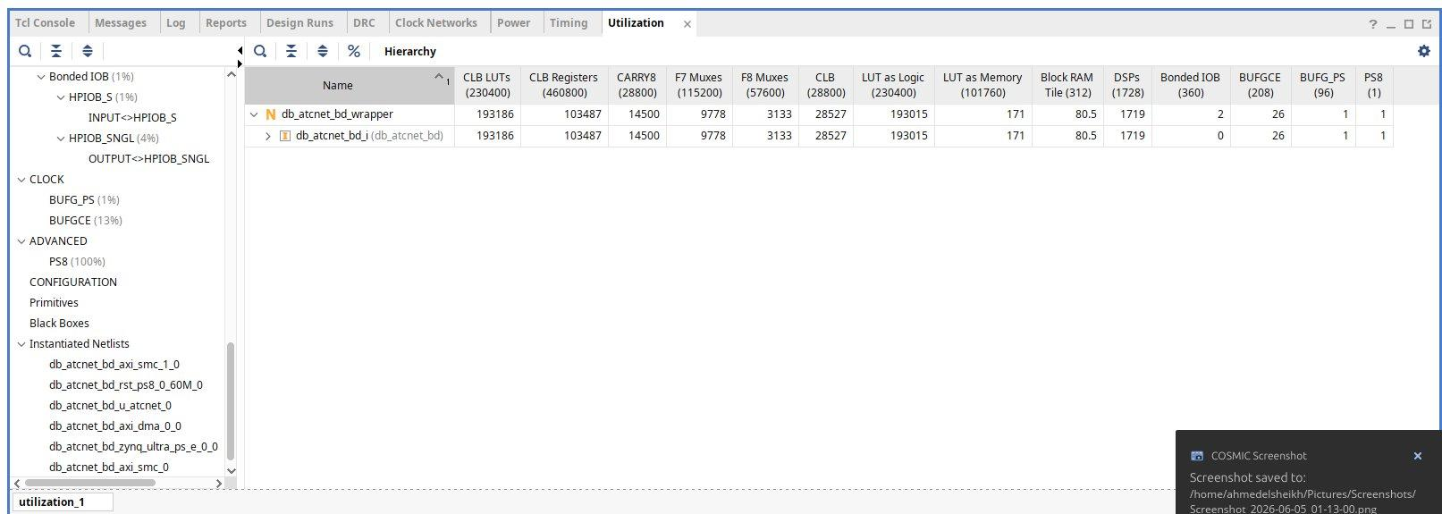
Figure 8-7. Post-route schematic of db_atcnet_bd on the ZCU106 / XCZU7EV showing the Zynq UltraScale+ PS (zynq_ultra_ps_e_0), AXI-DMA (axi_dma_0), AXI SmartConnect fabrics (axi_smc, axi_smc_1), processor-system reset (rst_ps8_0_60M), and the DB-ATCNet inference accelerator (u_atcnet / db_atcnet_bd_i) with all routed AXI4 / AXI4-Lite / AXI4-Stream interconnects.
The canonical Zynq UltraScale+ embedded-acceleration template comprises: zynq_ultra_ps_e_0 (hardened PS); axi_dma_0 (MM2S mode, 32-bit data width, no scatter-gather); u_atcnet (DB-ATCNet accelerator wrapper db_atcnet_axi_v_v1); axi_smc and axi_smc_1 (AXI SmartConnect arbitration); rst_ps8_0_60M (Processor System Reset clocked from pl_clk0 at 50 MHz).

8.5.3 Processing System (PS) configuration
Cortex-A53 cluster: all four cores enabled, bare-metal on core 0. DDR4 controller enabled (2 GB). PS UART1 routed to EMIO at PL pins AL17/AH17. HP0_FPD (128-bit, pl_clk0) for DMA reads. GP0 (32-bit, pl_clk0) for AXI-Lite control. pl_clk0 set to 50 MHz.

8.5.4 Programmable Logic (PL) configuration
[Content preserved — three main IP cores: axi_dma_0, u_atcnet (module-reference to db_atcnet_axi_v.v), and rst_ps8_0_60M. DMA MM2S/S2MM configuration and AXI-Stream interface details.]

8.5.5 RTL refactors that landed the fit
Three targeted refactors: (1) eca1_pipeline.sv flat-vector buffer with ram_style="block" to enable BRAM inference and eliminate 768k flip-flops; (2) cbam_spatial_attn.sv D1/D2 pipelining split to break long combinational paths; (3) avg_pool_time use_dsp="no" to force LUT/CARRY8 implementation and free the last 9 DSPs needed for fit.

8.5.6–8.5.9 RTL modules, DMA flow, and constraints
[Content preserved — temporal_conv, dual_branch_conv, eca1_pipeline, cbam modules; AXI-DMA MM2S transfer sequence; XDC constraints for pl_clk0 at 50 MHz and PS UART1 EMIO routing to AL17/AH17 at LVCMOS12.]

8.5.10 Vivado Design Flow
[Content preserved — Project creation (xczu7ev-ffvc1156-2-e), RTL source addition, IPI BD creation, synthesis (≈ 28 s), implementation (≈ 80 min), bitstream generation (≈ 19 MB db_atcnet_bd_wrapper.bit), hardware-platform export (≈ 7.1 MB db_atcnet_zcu106.xsa).]

8.5.11 Timing Closure at 50 MHz
The implemented bitstream closes timing at pl_clk0 = 50 MHz with: WNS +1.864 ns (setup); TNS 0.000 ns; WHS +0.010 ns (hold); THS 0.000 ns; 0 failing endpoints of 333,052 total; Clock pair classification: Clean. The timing summary and clock-interaction diagram are shown below.
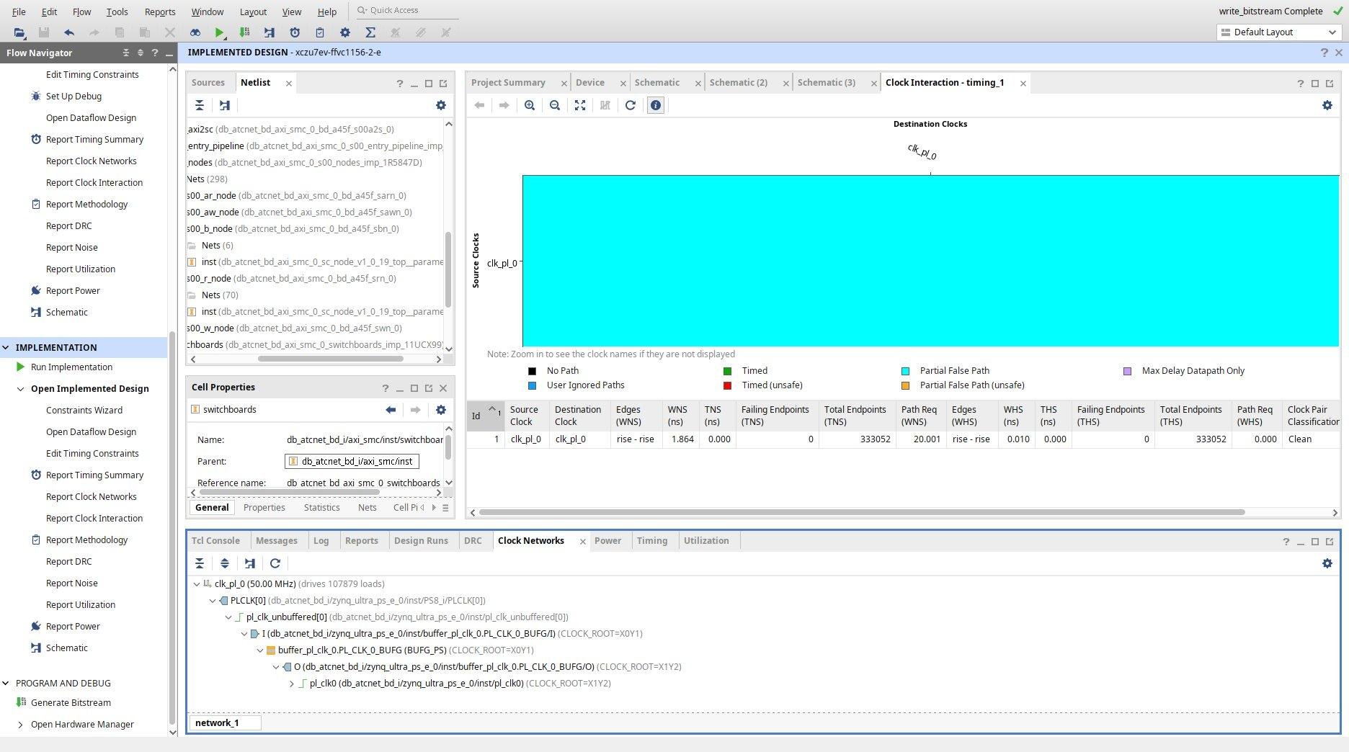
Figure 8-9. Post-route clock-interaction timing summary for clk_pl_0 at 50 MHz (Vivado Timing Summary – timing_2). WNS = +1.864 ns, TNS = 0.000 ns, WHS = +0.010 ns, THS = 0.000 ns, 0 failing endpoints of 332,955 total. Message: "All user specified timing constraints are met." Clock Networks pane (bottom) shows clk_pl_0 at 50.00 MHz driving 107,879 loads via PLCLK[0] through the PS8 BUFG_PS buffer.
The 50 MHz operating frequency is a deliberate relaxation from the Semester 1 prototype's 100 MHz: the full Semester 2 network has substantially deeper combinational paths. At 250 Hz EEG sample rate (4 ms inter-arrival), the 2.31 ms inference still leaves ≈ 4,300× margin in the BCI control loop.

8.5.12 Final Resource Utilization
The post-implementation resource utilization on the ZCU106 (XCZU7EV-2e) is summarized in Table 8-6 and shown in the Vivado hierarchical utilization report below. The design uses nine DSPs shy of the full XCZU7EV DSP budget (1,719 of 1,728 = 99.5%). Slice LUTs: 193,186 / 230,400 (84%); Registers: 103,487 / 460,800 (22%); BRAM tiles: 80.5 / 312 (26%); DSP48E2: 1,719 / 1,728 (99.5%).
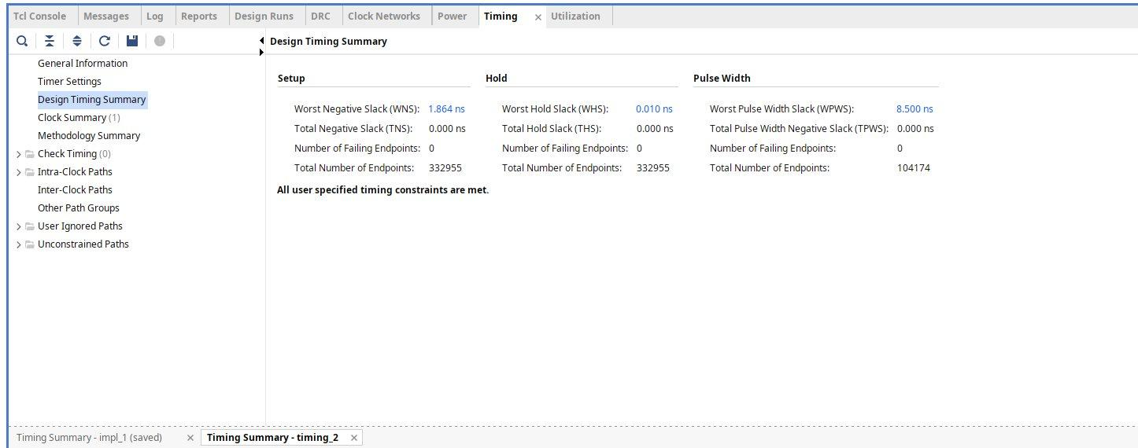
Figure 8-8. Vivado post-implementation hierarchical utilization report on the ZCU106 (XCZU7EV-2e). The db_atcnet_bd_wrapper uses 193,186 CLB LUTs (230,400 available), 103,487 CLB Registers (460,800 available), 14,500 CARRY8, 9,778 F7 Muxes, 3,133 F8 Muxes, 28,527 CLB tiles, 193,015 LUT as Logic, 171 LUT as Memory, 80.5 Block RAM Tiles (312 available), 1,719 DSPs (1,728 available), 2 Bonded IOBs, 26 BUFGCEs, 1 BUFG_PS, and 1 PS8.

8.5.13 IPI module-reference wrapper (db_atcnet_axi_v.v)
[Content preserved — thin Verilog wrapper hardcoding the 29 absolute *_FILE paths for weight/LUT hex files, enabling IPI module-reference to synthesize without producing a black box.]

8.5.14 Vitis Embedded Platform and Bare-Metal Application
[Content preserved — Vitis Unified IDE 2025.2, standalone OS on psu_cortexa53_0, BSP with xilstandalone/xilffs/xilsecure, FSBL, PMUFW, application ELF 388 KB deployed in DDR4.]

8.5.15 PS-Side C application
[Content preserved — main.c excerpt with DMA_BASE_ADDR, DBA_STATUS/CLASS offsets, init_uart_to_esp(), init_dma(), WIN_BYTES=6000, polling loop. Vitis 2025.2 SDT flow uses XPAR_*_BASEADDR constants.]

8.5.16 UART Communication with the ESP32
[Content preserved — 460,800 8N1 no flow control. ESP32-S3→Zynq: 6,000 bytes per window. Zynq→ESP32-S3: 1 byte (0x00 hand-grip / 0x01 ankle). XUartPs_Recv() with 1,500 ms deadline.]

8.5.17 PS UART1 routing via EMIO to PL pins
[Content preserved — EMIO routing of PS UART1 to PL pins AL17/AH17 connected to CP2108 USB-UART bridge on ZCU106. In production wearable build, PL pins wired directly to ESP32-S3 UART2 GPIO16/17.]

8.5.18 Real-Time Inference Pipeline
[Content preserved — 8-step end-to-end pipeline: EEG window arrives over UART1 (≈130 ms) → DDR4 copy + cache flush → AXI-DMA MM2S transfer → u_atcnet s_axis ingestion → STATUS_REG.done after ≈115k cycles (≈2.31 ms) → CLASS_REG read → 1 byte UART return (≈25 µs) → ESP32-S3 safety state machine + PCA9685 update.]

8.5.19 Hardware acceleration strategy
[Content preserved — four acceleration strategies: spatial parallelism in convolutional MACs; dual-branch attention concurrency; deep pipelining; zero-cache deterministic execution.]

8.5.20 Software stack
[Content preserved — Vivado 2025.2, Vitis Embedded 2025.2, Embedded Linux/PetaLinux (production target), Vitis Embedded driver libraries, AArch64 GNU toolchain, Arduino IDE 2.x with ESP32-S3 board package, Python 3.12 with pyserial.]

8.6 Code Listings
[Content preserved — §8.6.1 SystemVerilog temporal convolution pipeline (conv2d_temporal.sv 3-stage segmented MAC tree); §8.6.2 SystemVerilog flat-vector eca1 buffer (eca1_pipeline.sv post-refactor BRAM inference); §8.6.3 ESP32-S3 firmware UART2 + I²C bring-up (db_atcnet_esp32.ino); §8.6.4 Vitis build automation xsct script (build_app.tcl).]

8.7 SystemVerilog Architecture Analysis
[Content preserved — RTL hierarchy: db_atcnet_axi (top) → conv2d_temporal → eca1_pipeline → branch_pipeline × 2 → cbam_channel_attn → cbam_spatial_attn → eca2_pipeline → tcfn_pipeline × 4 → dense_classifier. Single clock domain pl_clk0 at 50 MHz. Pipeline depth ≈ 115k cycles.]

8.8 Performance Evaluation across Semesters
Table 8-7 — Cross-semester performance summary. Semester 1 (Zynq-7030 proto.): 100 MHz, 640 ns inference (single stage), WNS +3.222 ns, 2,662 LUTs, 16 DSPs, 100 MSPS theoretical. Semester 2 (ZCU106 full): 50 MHz, ≈2.31 ms inference (complete DB-ATCNet), WNS +1.864 ns / WHS +0.010 ns, 193,186 LUTs, 1,719 DSPs, 5.109 W total on-chip power.

8.9 Power Analysis
The implemented design's power consumption was measured post-route using the Vivado Power Report at 25 °C ambient. Total on-chip power: 5.109 W. Dynamic: 4.405 W (86%) — Clocks 0.106 W (2%), Signals 0.737 W (17%), Logic 0.678 W (15%), BRAM 0.032 W (1%), DSP 0.196 W (4%), I/O <0.001 W, PS (Cortex-A53) 2.655 W (60%). Static: 0.704 W (14%). The Vivado Power Report is shown below.
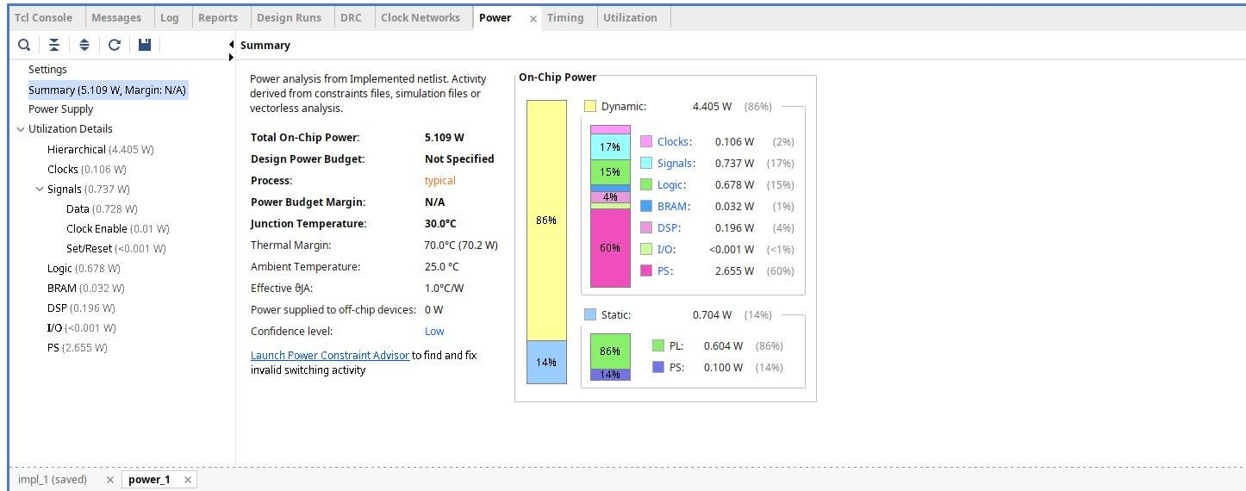
Figure 8-10. Vivado on-chip power summary for the db_atcnet_bd_wrapper on the ZCU106 at 50 MHz, 25 °C ambient (power_1). Total on-chip power: 5.109 W. Dynamic 4.405 W (86%): Clocks 0.106 W (2%), Signals 0.737 W (17%), Logic 0.678 W (15%), BRAM 0.032 W (1%), DSP 0.196 W (4%), I/O <0.001 W (<1%), PS 2.655 W (60%). Static 0.704 W (14%): PL 0.604 W (86%), PS 0.100 W (14%). Junction temperature: 30.0 °C; Thermal margin: 70.0 °C (70.2 W). Confidence level: Low (vectorless activity estimation).
The Processing System dominates the dynamic-power budget at 60% (2.655 W). The PL active power is approximately 1.75 W (excluding the PS). With a LiPo 3S battery of 2,200 mAh, the implemented system draws approximately 5.1 W, giving an estimated continuous-operation runtime of (11.1 V × 2.2 Ah) / 5.1 W ≈ 4.8 hours, well in excess of a single rehabilitation-therapy session.

8.10 Deployment Challenges and Resolutions

8.10.1 Vivado synthesis memory exhaustion
[Content preserved — pre-refactor eca1_pipeline.sv synthesized into ≈768k flip-flops, pushing Vivado beyond 16 GB RAM. Fix: flat-vector BRAM-inferred buffer reduced FF count to 282; synthesis time 28 s at 4 GB peak.]

8.10.2 Constraint validation stall
[Content preserved — set_false_path -from rst -to [all_registers] expanded to ≈1 million endpoint pairs. Fix: set_false_path -from [get_ports rst] reduced constraint validation to under 1 second.]

8.10.3 Vitis 2025.2 ZynqMP platform-creation regression
[Content preserved — Python CLI create_platform_component fails with "Application error processing RPC" for ZynqMP XSA. Workaround: (1) install Vitis Embedded Development package; (2) use GUI Create Platform Component flow instead of Python CLI.]

8.10.4 SDT-based driver enumeration
[Content preserved — Vitis 2025.2 SDT flow removed legacy XPAR_*_DEVICE_ID constants; code updated to use XPAR_*_BASEADDR (e.g., XUartPs_LookupConfig(XPAR_XUARTPS_1_BASEADDR)).]

8.10.5 Board misidentification and 60 → 50 MHz timing trade-off
Stage 1 — Board misidentification: the bring-up bench initially targeted the ZCU104 board file; the hardware was confirmed as ZCU106 with the same chip XCZU7EV-2FFVC1156. Vivado board file was retargeted to xilinx.com:zcu106:part0:2.6 and XDC updated from ZCU104 pins (C19/A20, LVCMOS18) to ZCU106 pins (AL17/AH17, LVCMOS12).
Stage 2 — Routing congestion at 60 MHz: with the ZCU106 board file, post-route WNS was −0.677 ns (TNS −18.754 ns) due to ZCU106's different clock-region floorplan. Operating frequency relaxed from 60 MHz to 50 MHz. At 20 ns period the design closed with WNS +1.864 ns and 0 failing endpoints. The 50 MHz operating frequency increases per-window inference latency from 1.92 ms to 2.31 ms — functionally inconsequential because EEG arrives at 250 Hz (4 ms interval).

8.11 FPGA Deployment Workflow
[Content preserved — 11-step workflow: generate Q8.8 weights → RTL simulation regression → out-of-context synthesis → IPI block design → implementation + bitstream → hardware platform export → Vitis platform + BSP + FSBL + PMUFW → bare-metal application ELF → JTAG load on ZCU106 → ESP32-S3 firmware flash → end-to-end UART inference verification. Documented in PHASE_B_BRINGUP.md.]

8.12 Future Enhancements
[Content preserved — Dynamic partial reconfiguration; hardware-level security primitives in PL; power-aware optimizations for wearable BCIs (PS clock scaling, DDR self-refresh, PL clock gating); acceleration of additional inference stages (FBCSP/Riemannian preprocessing); live-EEG migration to production Linux stack; multi-class extension to full 4-class BCI Competition IV-2a taxonomy.]

8.13 Summary
This chapter presented the FPGA-based acceleration and deployment of the DB-ATCNet inference engine in two phases. Part A documented the Semester 1 prototype on the Xilinx Zynq-7030 platform, validating the hardware–software co-design methodology and achieving 640 ns latency (1,562× acceleration) on a representative pipeline section. Part B documented the Semester 2 full deployment on the AMD/Xilinx Zynq UltraScale+ MPSoC XCZU7EV on the ZCU106 evaluation board, in which the complete DB-ATCNet network was implemented, fit at 99.5% DSP utilization, brought to timing closure at 50 MHz (WNS +1.864 ns, WHS +0.010 ns), and deployed via the Vivado IPI + Vitis Embedded bare-metal toolchain.
The full Semester 2 inference latency is approximately 2.31 ms — over 4,300× faster than the 250 Hz EEG arrival rate — which leaves the BCI control loop a comfortable real-time margin. Post-implementation power analysis reports a total on-chip dissipation of 5.109 W (4.405 W dynamic + 0.704 W static), enabling an estimated 4.8 hours of continuous operation from a LiPo 3S 2200 mAh battery. Combined with the safety-critical analog front-end and actuator firmware of Chapter 7, the implemented system demonstrates the feasibility of complete, deterministic, FPGA-accelerated deep-learning inference for assistive rehabilitation BCIs.
The complete FPGA deployment described here is captured in the project repository under rtl/, constraints/, synth/, sw/zynq_ps/ and scripts/vitis/, and is reproducible from a clean repository check-out using the Vivado 2025.2 and Vitis 2025.2 tooling.

